**COMPUTER ORGANIZATION AND ASSEMBLY LANGUAGE**

**LAB TASK 04**

Aliza Rizvi

58782

Q1: Print your SAP ID

**Code:**

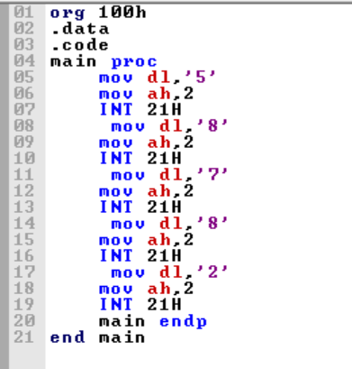

**Output:**

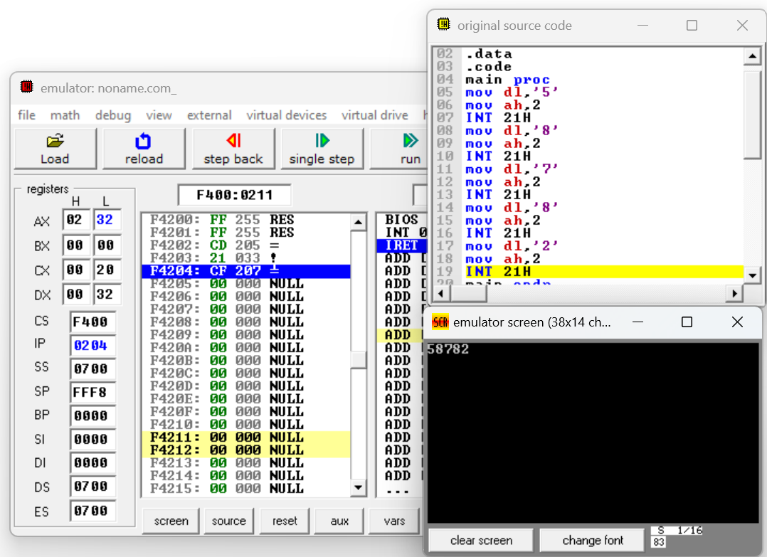

Q2: Write an assembly program to input two numbers from user, calculate their sum and display the result on screen

**Code:**

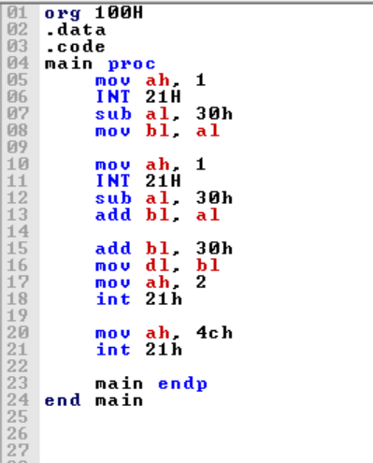

**Output:**

